caBIO Support for Drug Databank

Overview
The Canada Drug Databank (http://www.drugbank.ca/) is a repository containing detailed information on drugs (chemical, pharmaceutical, etc.) and drug targets (sequence, pathways, etc.). The repository contains over 4800 drug entries and 2500 drug targets and is available for download as open source. Permission was obtained from the drug databank to use and re-distribute drug data through caBIO (See References).
caBIO support for the Canada Drug Database involves providing access to additional drug information and drug targets through the caBIO API. This will augment existing information on drugs and drug targets obtained from the Cancer Gene Index project.

User Scenarios
The need for additional drug information was obtained via a scientific user scenarios provided by the caBIG ICR Nano WG (Stanford – Samira Guccione) in support of the caNanoLab project. The scientific user scenario is provided below [Table-1].
Sorafenib is a Raf kinase inhibitor that disrupts the key Ras/Raf/MEK/ERK cellular pathway which is up-regulated in renal cell carcinoma, glioblastoma multiforme (GBM) and stomach cancer. The drug has significant side effects and a scientist hypothesizes nanoparticle-assisted targeted delivery of the drug will reduce dosing and side effects.
A scientist interested in targeting this drug to GBM does research on possible nanoparticle-delivery systems that have the following properties:
- biocompatibility
- sufficiently long intravascular half-life to allow for repeated passage through and interactions with the activated endothelium
- the ability to have ligands and proteins conjugated on the surface in multivalent configuration to increase the affinity and avidity of interactions with endothelial receptors the ability to have functional groups for high-affinity surface metal chelation or radiolabeling for imaging
- the ability to encapsulate drugs
- the capability to have both imaging and therapeutic agents loaded on the same vehicle

Furthermore, the scientist looks for information on nanoparticles that could potentially target the GBM.
Integrin-targeted nanoparticles are identified. Synthesis involves UV cross linking an α_{v}β₃-integrin-targeting ligand attached to a lipid, a diacetylene phospholipid and a cationic lipid. These are sonicated to form polymerized vesicles and the α_{v}β₃-NP can serve as a scaffold for the attachment of therapeutic agents for imaging and therapy. The physical characteristics have been determined including size, zeta potential, IC₅₀ in a cell adhesion assay, and the effect of multivalency IC₅₀. Selectivity was also demonstrated in a receptor binding assay and it is not rapidly cleared from the target tissue. Previous studies have shown this particle to be highly stable, have no toxicity and to specifically target tumor associated vasculature in GBM when conjugated to GFP. Furthermore the particle has been used as an imaging agent when conjugated with Gd³⁺ or Indium¹¹⁺.
The α_{v}β₃-NP-Sorafenib is synthesized. Sorafenib absorption characteristics are available and the concentration of the drug in the system is determined via spectroscopy methods. Other physical properties are characterized.
The scientist investigates what data sets are available on in vivo use of the drug. A breast cancer xenograph subcutaneous model is found and cell lines from this system are also available. However toxicity data for the drug in animal models are not publicly available. The scientist contacts the drug manufacturer and begins in vitro testing. PK/PD in vitro tests, including drug uptake, toxicity and effectiveness, are performed in the model system cell lines, related and control cell lines by comparing the effects of drug alone, nanoparticle alone, and the combination. Next is in vivo testing with three established animal tumor models. The drug alone, nanoparticle alone, and the combination are administered and tumor size (and other parameters) is monitored.
Finally efficacy, dosing, and side effects of the current dosing protocol are compared with targeted nanoparticle delivery of Sorafenib.
Table-1 scientific user scenario provided by Samira Guccione (Stanford)
Additional user scenarios are as follows:
- Search for drugs based on pathway interactions (e.g. Display drugs that are RAF Kinase Inhibitors)
      - Note: Drug annotations on pathways can be displayed within the Cytoscape network interactions viewer
    - Display all the pathways that are affected by a specific drug to demonstrate any downstream effects. For example, if I use a drug that inhibits RAF Kinase, what pathways are impacted. This will allow for future “What If” scenarios to identify potential drug combinations. For example, if a drug adversely impacts a pathway or pathway component, can another drug be introduced to offset the effect.
- Search for drugs associated with disease (current Cancer Gene Index user scenario)

Technical Approach

Data Loading
Data from the Canada Drug Bank is available for download from the Download site: http://www.drugbank.ca/downloads. The current version is Version 2.5. Release 1 was deployed in Jan 05 and Release 2 in Jan 08 with 600 new drugs. Release 2.5 (per release notes) does not contain any new data as compared release 2.0.
There are a variety of data formats available for download [Table-2]
Data Type | Download Format
Drug Target Sequences | FASTA (Separate Download for Protein and Gene Sequences)
Metabolizing Enzyme Sequences | FASTA for Protein Sequences
Biotech Drug Sequences | FASTA for Protein Sequences
Drug Structures | Structure Data File (SDF) Format [http://en.wikipedia.org/wiki/Chemical_table_file#SDF]
All Drug Data | Flat Files (Zip File Containing Drug Card Format – 27 MB)  Note: Contains additional descriptive information
Table-2 Available Formats
The approach will involve parsing the Drug Card Format into the caBIO database as it contains the necessary descriptive information.
Additionally, data provenance information should be updated to include information from the following citations:
- DrugBank: a knowledgebase for drugs, drug actions and drug targets. Wishart DS, Knox C, Guo AC, Cheng D, Shrivastava S, Tzur D, Gautam B, Hassanali M. Nucleic Acids Res. 2008 Jan;36(Database issue):D901-6.
PMID: 18048412
- DrugBank: a comprehensive resource for in silico drug discovery and exploration. Wishart DS, Knox C, Guo AC, Shrivastava S, Hassanali M, Stothard P, Chang Z, Woolsey J. Nucleic Acids Res. 2006 Jan 1;34(Database issue):D668-72.
PMID: 16381955

API Extension
The technical approach involves extending the existing caBIO Drug-Disease-Gene model [Figure-1] to include additional attributes and objects associated with drugs, drug targets, and enzyme targets.
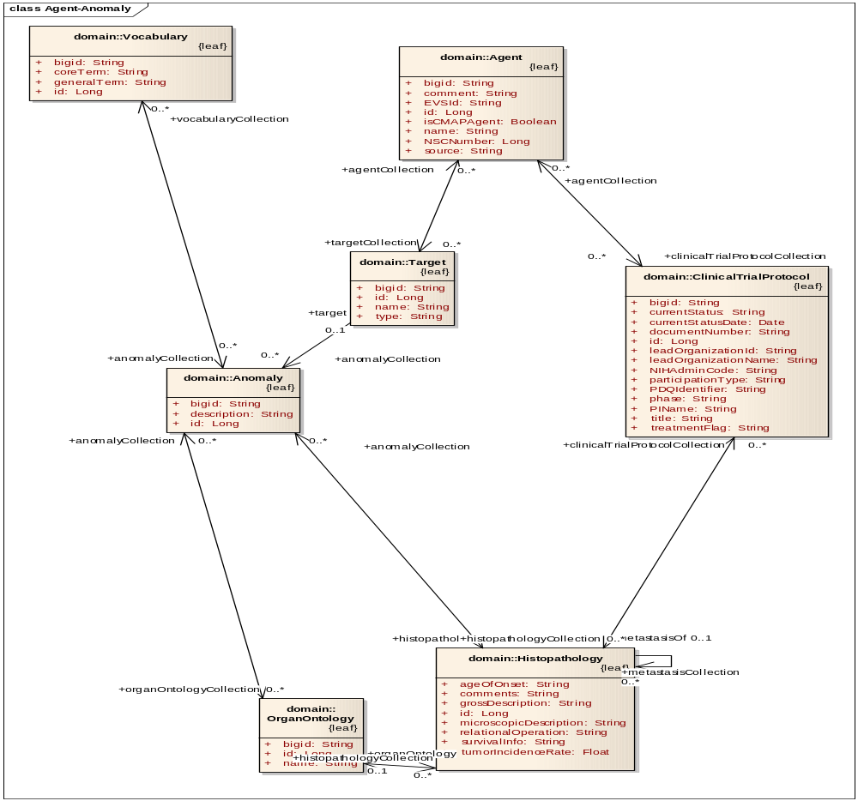
Figure-1 Existing caBIO Drug-Disease-Gene Model

There are a variety of additional objects and attributes that will need to be supported. Attributes associated with drug, drug targets, and enzyme targets are included in the DrugBank and provided in the table below [Table-3]. These attributes are available for viewing via the DrugBank site (Example Query: http://www.drugbank.ca/drugs/DB00398). Please note, not all attributes may be supported in caBIO. Additional analysis should be conducted to determine the attributes that should be supported.
Category | Attribute | Notes
Data Provenance | Version
 | Creation Date
 | Update Date
Drug | Primary Accession Number | DrugBank release 2.0 accession number
 | Secondary Accession Number | DrugBank release 1.0 accession number consisting of the 4 letter prefix and a 5 number suffix.
 | Name
 | Synonyms | Capture in EVS  (Example: http://nciterms.nci.nih.gov/NCIBrowser/GetRoleAndProperty.do?bookmarktag=1&conceptname=Sorafenib)
 | Chemical IUPAC Name
 | Brand Names
 | Brand Mixtures
 | Type | Approved, Investigational, Small Molecule -  Classification of Drug within DrugBank
 | Description
 | DrugBank ID
 | Chemical Formula | Concept in caNanoLab
 | Chemical Structure | Image
 | CAS Registry Number | Please note, there may be license restrictions in use of the CAS Registry Number:  CAS information is copyrighted by the American Chemical Society. Users who wish to incorporate CAS numbers into their own databases should see the details of the CAS usage policy[1].  A User or Organization may include, without a license and without paying a fee, up to 10,000 CAS Registry Numbers  or CASRNs in a catalog, website, or other product for which there is no charge.  ” (from http://en.wikipedia.org/wiki/CAS_registry_number
 | InChI Identifier | Link to International Union of Pure and Applied Chemistry
 | InChI Key | Link to International Union of Pure and Applied Chemistry
 | KEGG Drug
 | KEGG Compound
 | PubChem Compound | Link to NCBI PubChem which contains biological activities of small molecules
 | PubChem Substance | Link to NCBI PubChem which contains biological activities of small molecules
 | ChEBI ID | Link to ChEBI dictionary of molecular entities focused on ‘small’ chemical compounds from EBI
 | PharmGKB ID | Link to PharmGKB
 | HET ID | PDB identification number (if molecule is in PDB, ChemPDB or Ligand Depot)
 | GenBank ID
 | Drug ID Number [DIN] | Canadian Drug Identification Number
 | RxList Link | Manually curated online medical resource dedicated to offering detailed and current pharmaceutical information on brand and generic drugs since 95  http://www.rxlist.com/script/main/art.asp?articlekey=64467
 | PDRhealth Link | Consumer Web portal of the Physicians’ Desk Reference (PDR®), http://www.pdrhealth.com/help/about.aspx
 | Wikipedia Link
 | FDA Label | PDF Document with Date of FDA Approved Label
 | Material Safety Data Sheet
 | Synthesis Reference | Reference or patent number to description of drug's synthesis
 | Molecular Formula Format (Smiles) | Smiles and Smart format supported in caNanoLab
 | Molecular Weight (Average and Monoisotopic) | Concept in caNanoLab
 | Mass
 | State
 | Melting Point
 | Solubility (Experimental, Predicted) | Concept in caNanoLab as Boolean
 | Hydrophobicity | Concept in caNanoLab as Boolean
 | LogP (Experimental, Predicted)
 | LogS (Experimental, Predicted)
 | Permeability
 | Isoelectric Point
 | Mass Sprectrum
 | MOL File | File containing X, Y, Z Structure; Can be displayed using JMol
 | SDF File | Structure (Mol Extension)
 | PDB File | Note: Currently used by nanotech modeling and simulation tool (R. Cachua)
 | PDB ID
 | 2D Structure | Displayed using JMView
 | 3D Structure | Displayed using JMView (Note: Security Issue Trying to Display)
 | Drug Category | Anticancer, Antineoplastic, Protein Kinase Inhibitor
 | ATC Codes | Link to WHO classification
 | AHFS Codes | Text Description
 | Indication | Text Description
 | Pharmacology | Text Description  caNanoLab In Vivo Concept
 | Mechanism of Action | Text Description
 | Absorption | Text Description  Bioavailability % (caNanoLab In Vivo Concept)
 | Toxicity | Text Description  caNanoLab In Vivo Concept
 | Protein Binding | %
 | Biotransformation | Text Description
 | Half Life | Text Description  caNanoLab In Vivo Concept
 | Dosage Forms
 | Dosage Route | caNanoLab In Vivo Concept
 | Patient Information | Link to Patient Label Information
 | Contraindications
 | Interactions | Drugs that are known to interact, interfere or cause adverse reactions when taken with this drug
 | Drug Interactions | Refers to Drug-Drug interactions
 | Food Interactions | Refers to Food-Drug interactions
 | General References
 | Organisms Affected
 | Phase 1 metabolizing Enzymes | List of Enzymes Name of enzyme(s) that is known or thought to break down, metabolize or dispose of the drug
 | Targets | List of Receptors. Name of the protein or macromolecule (or other small molecule) that the drug is supposed to act upon. Some drugs act on multiple targets, so these fields may be repeated several times, reflecting the number of drug targets a specific drug may have.
Enzyme Target | Name
 | Gene Name
 | SwissProt ID
 | SNPs
 | Protein Sequence | FASTA Format
Drug Target | ID
 | Name | This refers to Protein Name / Small Molecule name, etc. of drug target
 | Synonyms | Maintained in EVS
 | Gene Name
 | Protein Sequence | FASTA Format
 | Number of Residues
 | Molecular Weight | Concept in caNanoLab
 | Theoretical pl
 | GO Classification | Function, Process, Component
 | General Function
 | Specific Function
 | Pathways
 | Reactions
 | Pfam Domain Function | Link to Sangar
 | Signals
 | Transmembrane Regions
 | Essentiality
 | GenBank ID Protein
 | UniProtKB/Swill-Prot ID
 | UniProtKB/Swill-Prot Entity Name
 | PDB ID
 | Cellular Location | List
 | Gene Sequence
 | GenBank Gene ID
 | GeneCard ID | Link to GeneCard - Proprietary
 | GeneAtlas ID
 | HGNC ID
 | Chromosome Location | Available in caBIO
 | Locus | More detailed location of the chromosomal position of the drug target (Already in caBIO? Cytogenetic Location)
 | SNPs | SNP Jam Report (Hash of dbSNP and HapMap)
 | General References | Pubmed Bibliographies
 | Drug References | Pubmed Bibliographies
Table-3 Attributes
Information on enzymes is currently available in the Protein/ProteinSequence objects in caBIO. Table-3 provides a comparison between DrugBank Enzyme target attributes and caBIO protein object attributes.
DrugBank Enzyme target Attributes
http://www.drugbank.ca/drugs/DB00172

Enzyme 1 Name | Proline oxidase
Enzyme 1 Gene Name | PRODH
Enzyme 1 SwissProt ID | O43272
Enzyme 1 SNPs | SNPJam Report
Enzyme 1  Protein Sequence | >sp|O43272|PROD_HUMAN Proline oxidase, mitochondrial precursor  MLEFVMREWKKSRKLLGQRLFNKLMKMTFYGHFVAGEDQESIQPLLRHYRAFGVSAILDY  GVEEDLSPEEAEHKEMESCSSAAERDGSGTNKRDKQYQAHRAFGDRRNGVISARTYFYAN  EAKCDSHMETFLRCIEASGRVSDDGFIAIKLTALGRPQFLLQFSEVLAKWRCFFHQMAVE  QGQAGLAAMDTKLEVAVLQESVAKLGIASRAEIEDWFTAETLGVSGTMDLLDWSSLIDSR  TKLSKHLVVPNAQTGQLEPLLSRFTEEEELQMTRMLQRMDVLAKKATEMGVRLMVDAEQT  YFQPAISRLTLEMQRKFNVEKPLIFNTYQCYLKDAYDNVTLDVELARREGWCFGAKLVRG  AYLAQERARAAEIGYEDPINPTYEATNAMYHRCLDYVLEELKHNAKAKVMVASHNEDTVR  FALRRMEELGLHPADHQVYFGQLLGMCDQISFPLGQAGYPVYKYVPYGPVMEVLPYLSRR  ALENSSLMKGTHRERQLLWLELLRRLRTGNLFHRPA

caBIO Protein Object Attributes http://cabioapi.nci.nih.gov/cabio42/GetHTML?query=Protein&Protein[@primaryAccession=O43272]

Bigid | hdl://2500.1.PMEUQUCCL5/GZUPRYT2AE
copyrightStatement | This Swiss-Prot entry is copyright. There are no restrictions on its use as long as its content is in no way modified and this statement is not removed.
id | 24562
keywords | Oxidoreductase; Disease mutation; Polymorphism; Mitochondrion; Transit peptide; Flavoprotein; FAD; Alternative splicing; Proline metabolism
name | Proline oxidase, mitochondrial
primaryAccession | O43272
secondaryAccession | Q9UF13; Q504W1; Q0P507; Q6NV86; O14680; Q147W8; Q59FI8
uniProtCode | PROD_HUMAN

caBIO ProteinSequence Object Attributes http://cabioapi.nci.nih.gov/cabio42/GetHTML?query=ProteinSequence&Protein[@id=24562]

bigid | hdl://2500.1.PMEUQUCCL5/Z2YH3PDF7G
checkSum | E5E72B3C595B4596
id | 24562
length | 516
molecularWeightIn  Daltons | 59231
value | MLEFVMREWKKSRKLLGQRLFNKLMKMTFYGHFVAGEDQESIQPLLRHYRAFGVSAILDY  GVEEDLSPEEAEHKEMESCTSAAERDGSGTNKRDKQYQAHRAFGDRRNGVISARTYFYAN  EAKCDSHMETFLRCIEASGRVSDDGFIAIKLTALGRPQFLLQFSEVLAKWRCFFHQMAVEQ  GQAGLAAMDTKLEVAVLQESVAKLGIASRAEIEDWFTAETLGVSGTMDLLDWSSLIDSRT  KLSKHLVVPNAQTGQLEPLLSRFTEEEELQMTRMLQRMDVLAKKATEMGVRLMVDAEQT  YFQPAISRLTLEMQRKFNVEKPLIFNTYQCYLKDAYDNVTLDVELARREGWCFGAKLVRGAY  LAQERARAAEIGYEDPINPTYEATNAMYHRCLDYVLEELKHNAKAKVMVASHNEDTVRFAL  RRMEELGLHPADHQVYFGQLLGMCDQISFPLGQAGYPVYKYVPYGPVMEVLPYLSRRALE  NSSLMKGTHRERQLLWLELLRRLRTGNLFHRPA

In the development of the object model extensions, the caBIO team will work with closely with the caNanoLab team to re-use applicable objects and attributes in support of the nanotech user scenario.

Portlet Enhancements
The caBIO Portlet will be updated to:
- Allow users to search for drugs based on pathway interactions.
- Allow users to Display all the pathways that are affected by a specific drug to demonstrate any downstream effects.
This could be included in a caBIO PID focused portlet and/or templated search.

Issues/Risks

Level of Effort
Need to determine which (or all) attributes should be maintained in caBIO.

Tasks
- Update and Annotate Object Model
- Implement Object Model and Convenience APIs
- Update Data Model
- Update Data Provenance Information
- Create Data Load Scripts
- Transform Data (Data Mapping)
- Validate Data Load
- Implement Templated Search in caBIO Portlet

Estimated Level of Effort
Please note, estimates will need to be reviewed once initial requirements are determined.
1 Software Engineer – 3 Months (2 Months API, 1 Month Portlet Update)
1 Data Architect – 3 Months
1 QA Support – 3 Weeks
Total LOE: 3 Months

References
http://www.drugbank.ca/
http://www.drugbank.ca/fields
http://129.43.27.140/ncidb2/faq.html
http://www.cas.org/aboutcas/index.html
Consent to Use and Re-Distribute Data:
From: Craig Knox [mailto:cknox@ualberta.ca]
Sent: Thursday, February 05, 2009 6:26 PM
To: Gaheen, Sharon (NIH/NCI) [C]
Cc: info@redpoll.pharmacy.ualberta.ca
Subject: Re: Use and Re-Distribution of Drug Bank Data
Hi Sharon,

We are pleased that you will be using the data. Our only request is that we are cited in any publications that come out of your research.

Thanks, and let me know if you have any issues/questions.

Craig Knox

On 5-Feb-09, at 1:11 PM, Gaheen, Sharon (NIH/NCI) [C] wrote:

Good Afternoon,
I am writing to request the use and distribution of your drug bank data through our open source tool, caBIO - cancer Biomedical Informatics Objects (https://wiki.nci.nih.gov/display/ICR/caBIO). caBIO is an open source tool supported under the National Cancer Institutes (NCIs) cancer Biomedical Informatics Grid (caBIG) program (https://cabig.nci.nih.gov/) that provides API access to a variety of open source data repositories in support of cancer research.
Our nanotechnology scientists would like access to your data to assist in engineering nanoparticles as drug delivery devices and we would like to make your data accessible through caBIO APIs, which will then be consumed by our nanotechnology portal.
Please let me know if you need additional information and if you would be willing to permit us to use and re-distribute your data through our open source APIs.
Best regards,
Sharon
Sharon Gaheen (formerly Settnek)
NCI CBIIT/caBIG
SAIC Program Manager
Contractor
settneks@mail.nih.gov
(301) 451-6345

